Supplemental materials

Enhanced fluorescence of a porous Al₂O₃ film using gold nanoparticles on self-assembled CdSe/Au/Al₂O₃ heterojunctions

Zhongchen Bai^{1,2} , Jing Zhou^{1,2}, Man Peng², Zhengping Zhang² and Shuijie Qin²

1. College of Medicine, Guizhou University, Guiyang City, 550025, China
2. Guizhou Province Key Lab. for Photoelectric Technology and Application,
Guizhou University, Guiyang City, 550025, China

- AFM surface topography of porous Al₂O₃ film and that modified with Au nanoparticles
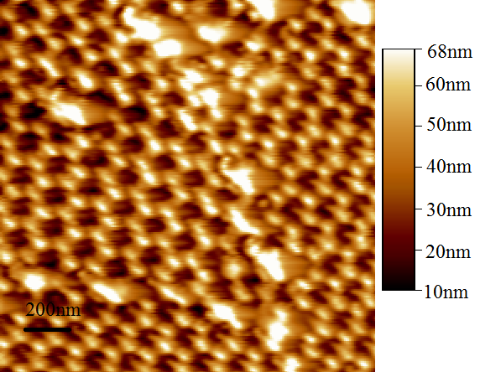 | 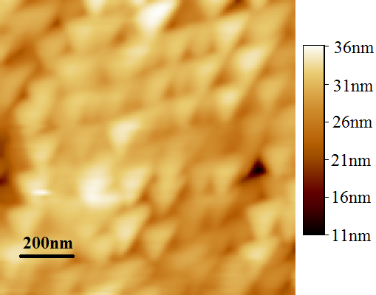  (a)  (b)
Fig.S1 (a). AFM surface topography of porous Al₂O₃ film. (b). AFM surface topography of porous Al₂O₃ film modified by gold nanoparticles using colloidal self-assembly method.

- The characterization of raw materials
- TEM of Au nanoparticles
The Au nanoparticle was monodisperse commercialized QDs. it was dispersed into ethanol. Its surface was packaged with citric acid molecules. Its size of TEM was about 15nm. And its morphology was sphere.
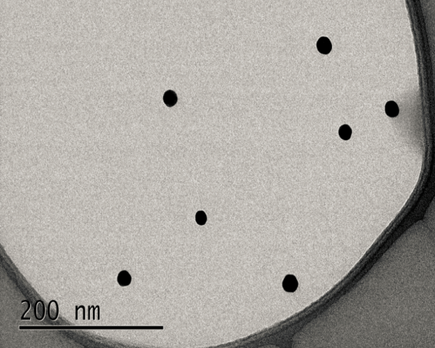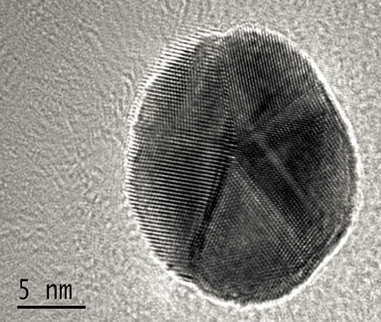
(b)

(a)

Fig.S2. The TEM of Au nanoparticles. (a) The TEM of Au nanoparticles; (B) The enlarge picture of (a).
- The morphology of porous Al₂O₃ film
The morphology of porous Al₂O₃ film shows a honeycomb structure. Its size of pore is 70nm width and 5μm deep, which is a commercialized porous material. Its pore can confine the CdSe QDs and Au NPs, and combine with the carboxyl of QDs and Au NPs via the interaction of static electricity due to the positive charge on the surface of porous Al₂O₃ film.
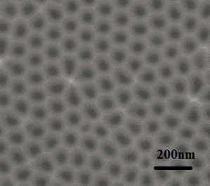
Fig.S3. The SEM of porous Al2O3 film.
(3)The TEM of CdSe QDs raw materials

The crystal phase and size of CdSe QDs are showed in Figure S4. Figure S4(a) represents the CdSe QD cluster, which is 128nm. We further enlarge view on the edge of the cluster, the size and crystal phase from single CdSe QD is clearly showed in Figure S4(b) and its size is about 3.5nm.
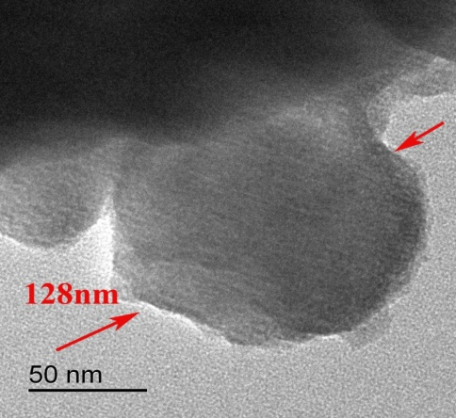  (b)  (a)  (a) | (b)
Figure.S4. The TEM graphics of CdSe quantum dots power. (a) CdSe colloidal quantum dots cluster, (b) the crystalline phase of CdSe quantum dot on edge of cluster (a).

To further observe its crystal phase, we characterized it by using the XRD. It is clearly represented that the crystal phase are (111), (220) and (311) in Figure S5. And that the CdSe QD has a zinc-blende structure.

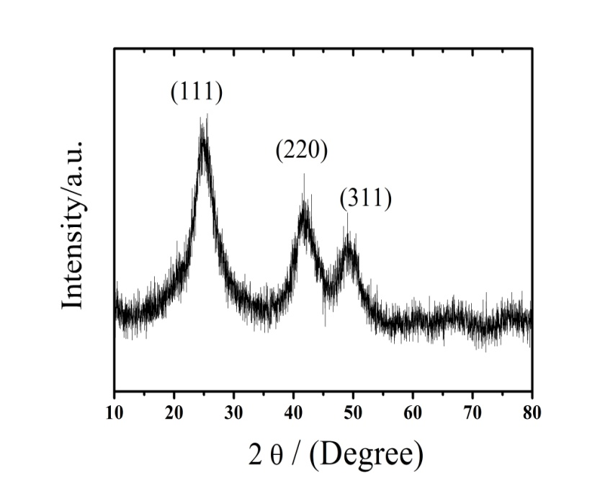
Figure S5. XRD of CdSe quantum dots power.
- Chemical components of CdSe QDs

The raw material (CdSe QDs) we prepared included oleic acid, methyl alcohol, acetone and paraffin in process of Sol-Gel methods. The ethyl alcohol is used for washing CdSe QDs. FTIR result is shown in Figure S6. Some chemical elements will be observed in FTIR spectrum. Nearby 3437cm-1 derives from the stretching vibration of O-H bound. 2958cm-1、 2922cm-1、 2850cm-1 are the stretching vibration of C-H bound. 1635cm-1 is the stretching vibration of C=C bound. 1377cm-1 and 1461cm-1 are the vibration peak of alkane. Nearby 723cm-1 is characteristic absorption of CdSe quantum dots. So, CdSe QDs are packaged by oleic acid, which can combine with other materials via the absorption or chemical bonding.

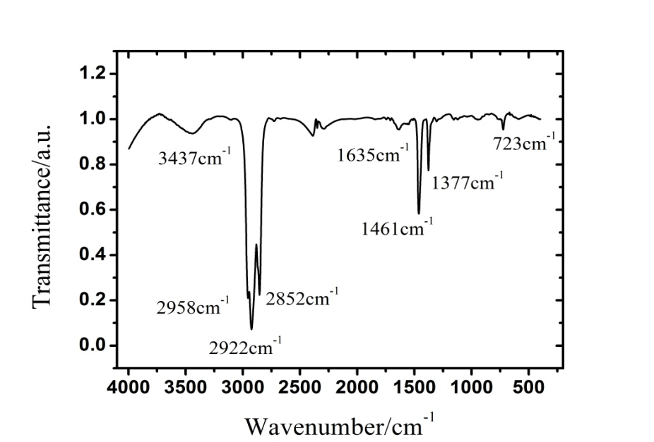
Figure S6. FTIR of CdSe quantum dots.

